Recipient’s Name: ___________________________________________

Recipients Address: ___________________________________________
(inc Postcode pls)
___________________________________________

___________________________________________

Recipient Contact Number: ___________________________________________

Household Size: Adults ____ Children: 0-4* __ 5-11 __ 12-18 __

*pls note ages/nappy size in special requirements

Reason for Referral: ___________________________________________
(eg Benefit delay/debt/etc)

Referral duration 1 wk ☐ 2 wk ☐ 3 wk ☐ 4 wk ☐ 5 wk ☐ 6 wk ☐
(tick one – recipients can have support for up to 6 weeks before needing a further referral)

Special Requirements: ___________________________________________
e.g. special diet, diabetic, nappies

___________________________________________

Referring Agency: ☐ Doncaster Community Hub
☐ Key Worker/Social Worker**
☐ Doctor’s Surgery**
☐ School**
☐ Christian Church**

**name of organisation: ___________________________________________

Referrer: (pls print) ___________________________________________

Referrer Email: ___________________________________________

Referrer Signature: ___________________________________________

Referral Date: ___________________ (pto for GDPR)
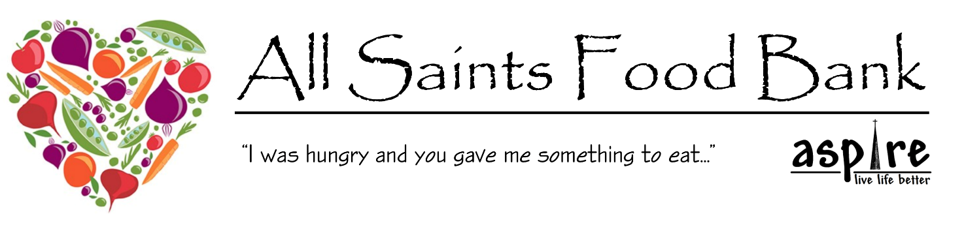
GDPR Privacy Notice

The EU General Data Protection Regulation (GDPR) is a privacy and data protection regulation in the European Union effective from May 25 2018. The GDPR imposes new obligations on organisations that control or process personal data and introduces new rights and protections for EU citizens. We are committed to ensuring that your privacy is protected and we strictly adhere to the provisions of all relevant Data Protection Legislation, including GDPR, ensuring all personal data is handled in line with the principles outlined in the regulation.

Data from referring agencies will only be used for the purposes of processing or querying a referral. Data will be kept securely for a reasonable length of time to ensure transparency of the Food Bank operation.

Data concerning the Recipient will be kept and used to monitor frequency of access to the Food Bank. If a referral is made for someone living outside the villages of Woodlands, Highfields, Adwick, Carcroft and Skellow and there is another Food Bank that the individual might be able to access we reserve the right to contact that Food Bank and enquire if an individual has accessed their provision.

Data will be kept for a reasonable period of time to enable the monitoring of referrals and access to the Foodbank. Anonymised data may be used for the purposes of reporting Food Bank usage and for future grant applications.

For the purposes of GDPR Rev Stephen Gardner of All Saints Church will be the nominated Data Controller and Processor.

FOOD BANK USE ONLY

Referral Received: ____________________

Recipient Reference: ____________________________________________

Referral Reference: ____________________________________________

